Ideation Phase
Brainstorm & Idea Prioritization Template

Date | 2 October 2026
Team ID | SWTID-2026-6670
Project Name | Implement Client Script & UI Policy (Incident)
Maximum Marks | 4 Marks

Brainstorm & Idea Prioritization Template:
Brainstorming provides a free and open environment that encourages everyone within a team to participate in the creative thinking process that leads to problem solving. Prioritizing volume over value, out-of-the-box ideas are welcome and built upon, and all participants are encouraged to collaborate, helping each other develop a rich amount of creative solutions.
Use this template in your own brainstorming sessions so your team can unleash their imagination and start shaping concepts even if you're not sitting in the same room.
Reference: https://www.mural.co/templates/brainstorm-and-idea-prioritization
Step-1: Team Gathering, Collaboration and Select the Problem Statement
Problem statement (How might we...?) | How might we enforce consistent, accurate data entry on Incident records so that High-impact incidents are always complete, correctly owned and routed, without relying on manual checks?
Team gathering | Four participants with ServiceNow Incident Management and form-configuration knowledge joined a 1-hour session.
Goal | Decide which UI Policies and Client Scripts will enforce data integrity on the Incident form and list view.
Key rules of brainstorming | Stay in topic. Encourage wild ideas. Defer judgment. Listen to others. Go for volume. If possible, be visual.
Step-2: Brainstorm, Idea Listing and Grouping
Each participant wrote down ideas that address the problem statement (10 minutes).
Participant 1 | Participant 2 | Participant 3 | Participant 4
Make Assignment group mandatory when Impact = High | Auto-set Urgency when Impact changes to High | Block save if Assigned To is empty on High impact | Block State edits from the list view
Make Urgency read-only for High impact | Show an info message when Urgency is auto-set | Show an inline error box on Assigned To | Alert pointing user to open the Incident form
Reverse the policy when Impact is lowered | Warn user before changing a locked field | Server-side Business Rule as a backup check | Role-based exceptions for list editing

Similar ideas were then clustered into themes (20 minutes).
Theme | Ideas in the group | Status
A. Conditional field behaviour (UI Policy) | Mandatory Assignment group, read-only Urgency, reverse if false | Implemented
B. Auto-population & guidance (onChange) | Auto-set Urgency to High and show info message when Impact = High | Implemented
C. Save-time validation (onSubmit) | Block save and show error if Assigned To is empty on High impact | Implemented
D. List protection (onCellEdit) | Block State changes from list view with an alert message | Implemented
E. Extended controls (future scope) | Server-side Business Rule, role-based exceptions, notifications, compliance dashboard | Future scope
Step-3: Idea Prioritization
Ideas were placed on the Importance vs Feasibility grid (20 minutes). Ideas in the upper-right area were selected for implementation in this project.
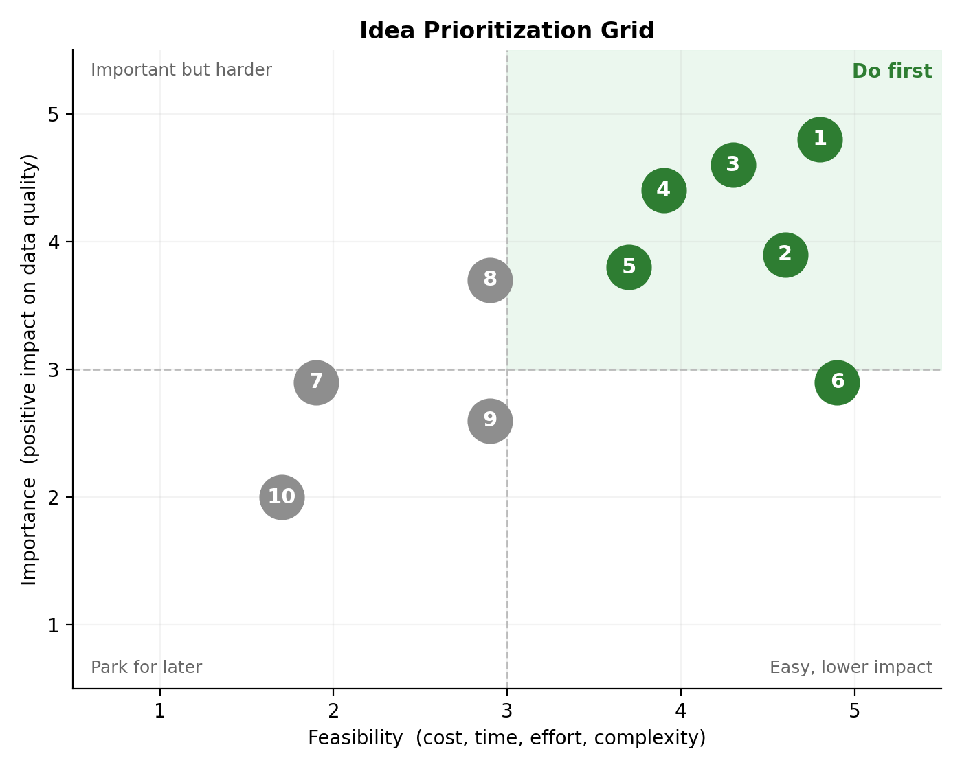
# | Idea | Importance (1-5) | Feasibility (1-5) | Decision
1 | Mandatory Assignment group when Impact = High | 5 | 5 | Selected
2 | Urgency read-only for High impact | 4 | 5 | Selected
3 | Auto-set Urgency on Impact change (onChange) | 5 | 4 | Selected
4 | Block save without Assigned To (onSubmit) | 5 | 4 | Selected
5 | Block State edits in list view (onCellEdit) | 4 | 4 | Selected
6 | Reverse if false for UI Policy actions | 3 | 5 | Selected
7 | Role-based exceptions for list editing | 3 | 2 | Later
8 | Server-side Business Rule backup | 4 | 3 | Later
9 | Notifications for unassigned High incidents | 3 | 3 | Later
10 | Dashboard of non-compliant incidents | 3 | 2 | Later

